# CYB220 Final exam – Fall 2024

**Name:** Jake Gendreau

**Due:** Wed, Dec 11th, 2024, 11:59 pm

**Turn in:** (1) The vulnerable code version (.c or .cpp file) with the good code left in the comments.

(2) The answered exam file (this file with your answers in it).

**Points:** 100 pts

**Objective:** In this final exam, you will show what you learned this semester, especially writing more secure code and using static and dynamic analysis tools to find/trigger bugs and vulnerabilities in the program.

**Overview:**

The exam has four tasks:

1. (50 pts) Write a c/c++ program based on the requirement.
2. (15 pts) Use a static analysis tool and a dynamic analysis tool to analyze/test your program.
3. (20 pts) Inject five vulnerabilities based on the 2024 CWE top 25 software weaknesses.
4. (15 pts) Use the same static and dynamic analysis tools to analyze/test the vulnerable version of the program to see what they can find.

------------------------------------------------------------------------------------------------------------------------------

### (50 pts) Task 1: Design and implement a simple program that analyzes user input.

Create a C/C++ program that reads user input and analyzes them.

* (8 pts)The program continues asking for input until the user enters “exit” to terminate the program.
* Please use character arrays (NUL-terminated) to store the user input. The use of the string library is not allowed this time.
* For each round, just read in no more than 999 characters. If the user enters more than 999 characters, cut them off and only keep the first 999 characters. You should add a NUL-terminator at the end of the 999th character.
* After the user enters input, your program should analyze it, modify it, and print out the results one by one automatically (See detailed requirement below).
* Then, ask for another user input until “exit” is received.

In each round, after the user enters input, do these analysis and modifications, and display the results for each of them one by one.

1. (7 pts) Implement a function to count the number of vowels in the user input and print the numbers of each of the vowels separately. Such as a-123, e-328, i-100…
2. (7 pts) Write a function that takes a character array as input, reverses the string, and prints them.
   * E.g., Hey! Are you ready for the winter break? → break? winter the for ready you Are Hey!
3. (7 pts) If the input has one or more numbers in it, print the numbers and the sum of them.
4. (7 pts) Use a pointer to step through the array elements to search for words ending with “ing”, print them, and also the count of these -ing words! In addition, print the one with the most characters.
   * Note: only words ending with ing, such as “reading” and “working”. The words “surprisingly” and “single” do not count!
   * Print the one with the most characters → If you have “reading”, “lying”, “sleeping”, “surprising”, the one word with the most characters is “surprising” (10 chars).
5. (7 pts) Create a function that removes all the white spaces in the input. Print the modified user input.
6. (7 pts) Design a function that compresses the user input by replacing consecutive duplicate characters with a single character followed by its count (For example, "aaabbc" becomes "a3b2c").

### (15 pts) Task 2: After you have your program written:

1. Test your program yourself. Screenshot the output to prove your program is running correctly.

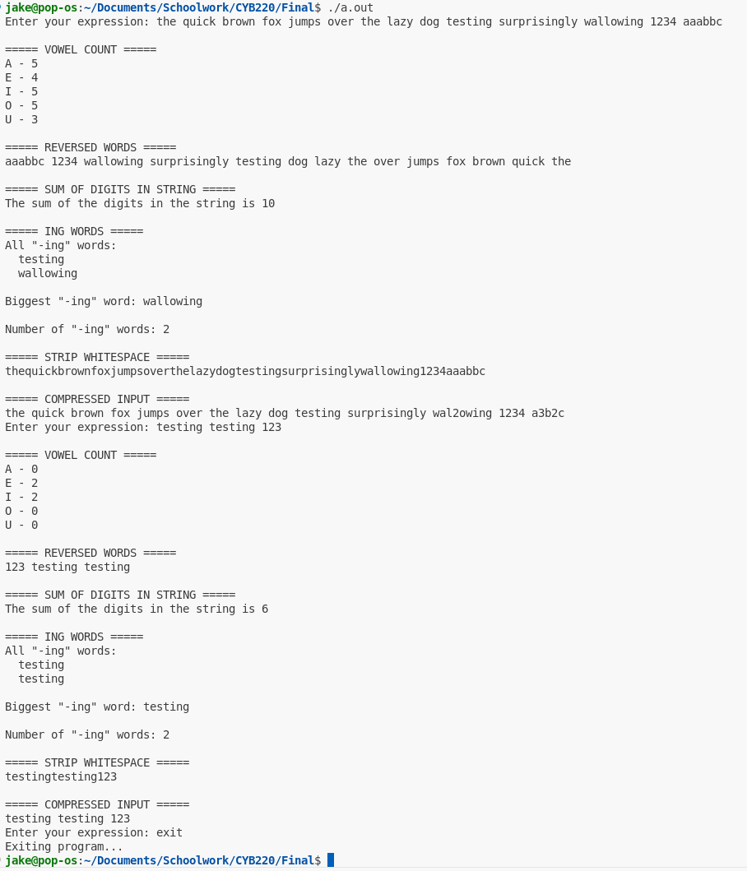

1. Run the static analysis tool, cppcheck, to see what bugs it can find (if any).

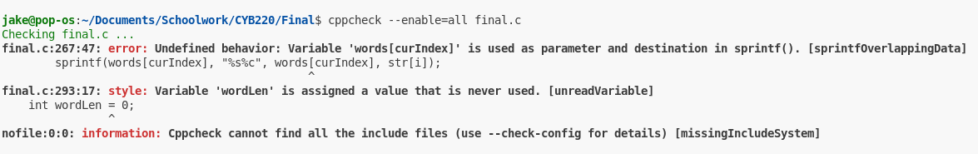

The only error that I have is that my sprintf() function uses one string as both the destination and a source. This is not an issue since I am only appending to the string, so I overwrite the contents of the string with the existing contents.

the style warning is about initializing a variable to an unused value, since it gets reset within the loop. Again, this isn't an issue since it's better to have an initialized, unused value than an uninitialized value.

the last warning is about included files. I do not know how to make it go away.

1. Run the dynamic analysis tool, AFL, to fuzz your program for 30 minutes.

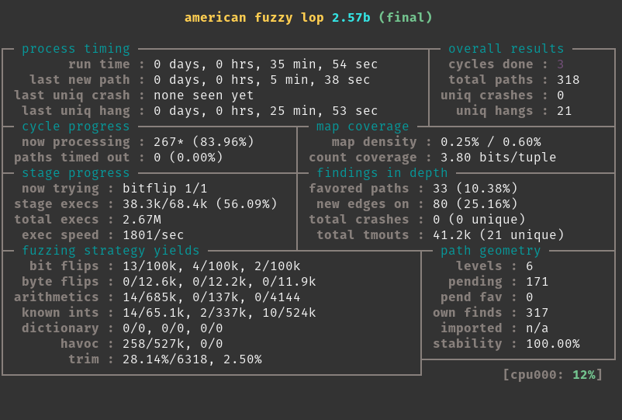

I had no crashes using AFL for 35 minutes.

1. If any bugs are found by these tools, make sure you fix them before moving to task 3.

### (20 pts) Task 3: Take a look at the 2024 CWE Top 25 Most Dangerous Software Weaknesses ([**https://cwe.mitre.org/top25/archive/2024/2024_cwe_top25.html**](https://cwe.mitre.org/top25/archive/2024/2024_cwe_top25.html)**)**

**Identify 5 CWEs from the top 25, and inject them into your code. 4 pts each.**

**Note: simply comment out your good code and inject the vulnerable code after it (in the same file).**

**----------- 1. CWE ??? -----------**

**ID and title:** CWE ??? – Improper …

**CWE Description:** ???

**Your original /good code:**

**[paste your code here or a screenshot of the code snippet]**

**Your injected vulnerable code:**

**[paste your code here or a screenshot of the code snippet]**

**A brief explanation of your vulnerable code:** ???

**----------- 2. CWE ??? -----------**

**ID and title:** CWE ??? – Improper …

**CWE Description:** ???

**Your original /good code:**

**[paste your code here or a screenshot of the code snippet]**

**Your injected vulnerable code:**

**[paste your code here or a screenshot of the code snippet]**

**A brief explanation of your vulnerable code:** ???

**----------- 3. CWE ??? -----------**

**ID and title:** CWE ??? – Improper …

**CWE Description:** ???

**Your original /good code:**

**[paste your code here or a screenshot of the code snippet]**

**Your injected vulnerable code:**

**[paste your code here or a screenshot of the code snippet]**

**A brief explanation of your vulnerable code:** ???

**----------- 4. CWE ??? -----------**

**ID and title:** CWE ??? – Improper …

**CWE Description:** ???

**Your original /good code:**

**[paste your code here or a screenshot of the code snippet]**

**Your injected vulnerable code:**

**[paste your code here or a screenshot of the code snippet]**

**A brief explanation of your vulnerable code:** ???

**----------- 5. CWE ??? -----------**

**ID and title:** CWE ??? – Improper …

**CWE Description:** ???

**Your original /good code:**

**[paste your code here or a screenshot of the code snippet]**

**Your injected vulnerable code:**

**[paste your code here or a screenshot of the code snippet]**

**A brief explanation of your vulnerable code:** ???

### (15 pts) Task 4: After you inject the five vulnerable codes into your program:

1. Run the static analysis tool, cppcheck, to see what bugs it can find (if any).

[PASTE YOUR SCREENSHOTS HERE]

[Explain the results]

1. Run the dynamic analysis tool, AFL, to fuzz your program for 30 minutes.

[PASTE YOUR SCREENSHOTS HERE]

[Explain the results]

**Now, you have finished all the tasks for the final exam.**

**Turn in:** (1) The vulnerable code version (.c or .cpp file) with the good code left in the comments.

(2) The answered exam file (this file with your screenshots and answers in it).

Make sure you double-check your submission to make sure you upload the correct files.